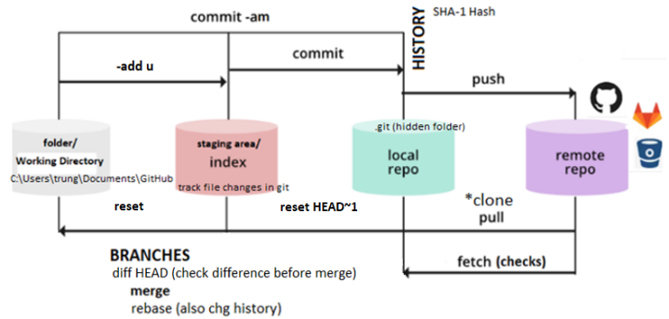

=== GitHub Desktop Setup (git GUI) ===

desktop.github.com

Step 01: Execute GitHubDesktopSetup-x64.exe

Step 02: Sign in to GitHub.com button

File > Options > Accounts > GitHub.com Sign in > Continue with browser

Step 03: Configure global git configuration

File > Options > Accounts > Git

Name: trungdullc

Email: 113845110+trungdullc@users.noreply.github.com

Default branch for name for new repositories: **main** or master

=== Create new repository on your hard drive ===

File > New repository Ctrl + n

Name: **test-repo**

Local path: C:\Users\trung.DESKTOP-G7C81CH\**Documents\GitHub**

Click on Initialize this repository with a README

Git ignore: None

License: None or MIT License <https://github.com/github/choosealicense.com>

Click Create Repository

=== Open repository in VSC ===

GitHub Desktop > Open in Visual Studio Code Ctrl + shift + a

VSC > File > Open Folder > C:\Users\trung.DESKTOP-G7C81CH\Documents\GitHub\test-repo

if popup (Git not found. Install it or configure it using the “git.path” settings means git not installed

=== git Setup ===

git (Version Control on **C**ommand **L**ine **I**nterface)

<https://git-scm.com/downloads>

Choosing the default editor used by Git: VSC instead of vim

Adjusting the name of the initial branch in new repositories:

Override the default branch name for new repositories: main

=== Create new index.html in VSC in repository and commit changes in GitHub Desktop ===

Create index.html

! + tab: creates template

Ctrl + s, in VSC

Go back GitHub Desktop (track changes)

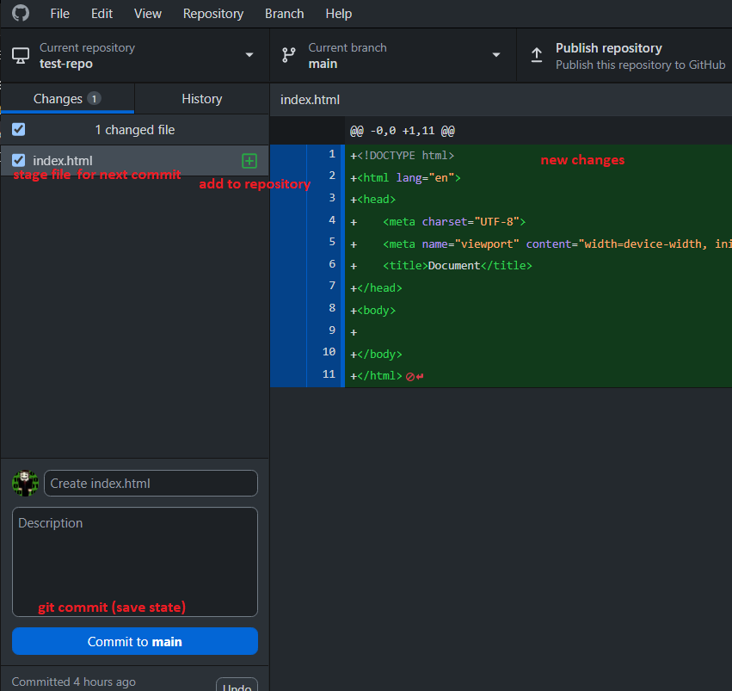

Click Commit to main **git commit**: save point

=== Publish this repository to GitHub from GitHub Desktop ===

Click Publish repository

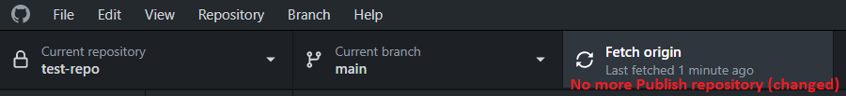

Note: Fetch origin: **git fetch** checks if GitHub version has changes vs **git pull** where copies from GitHub

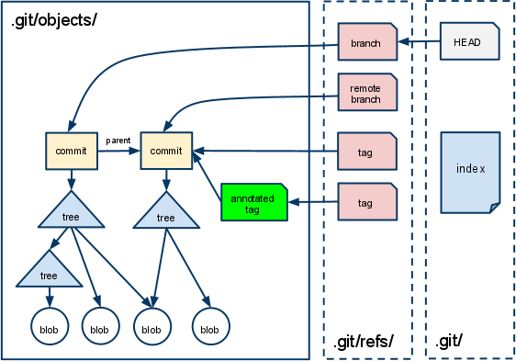

=== View uploaded test-repo repository on GitHub ===

GitHub (Website to host git repositories)

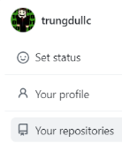

Click Your repositories > test-repo

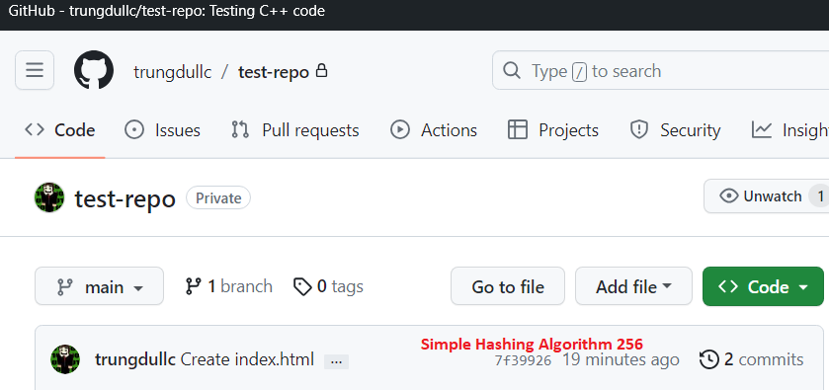

Note: Not recommended to edit files directly on GitHub, do in VSC

=== Create secret.txt in VSC untrack file/folders in GitHub Desktop===

Create secret.txt in VSC

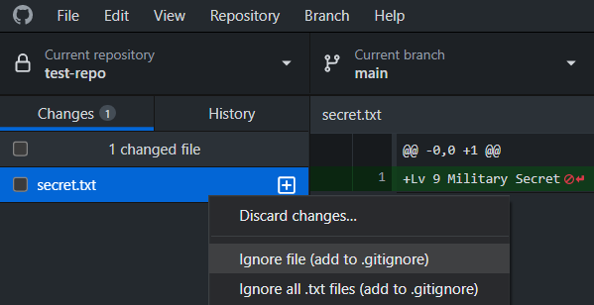

Ignore file in GitHub Desktop

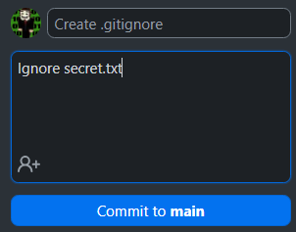

Note: Commit to main only save changes on local not origin of GitHub

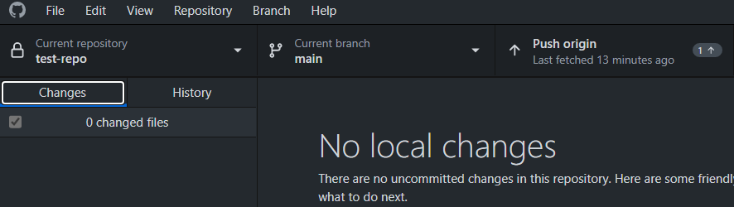

Note: **git push**: update GitHub version from local

Important: Notice secret.txt didn’t get uploaded to GitHub

=== Change existing files(index.html) in VSC ===

Update index.html and save in VSC

See changes in GitHub Desktop

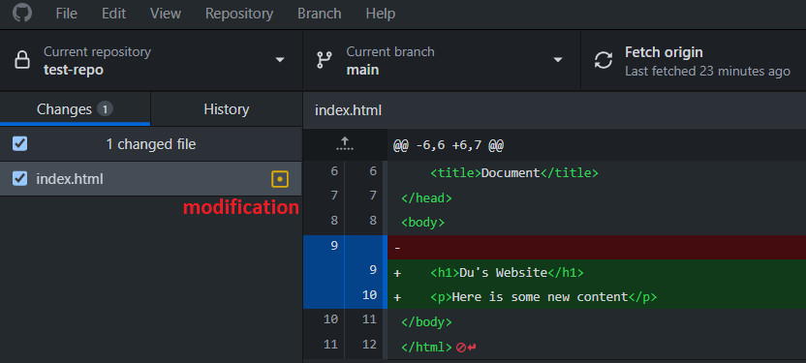

Click commit changes to main

Click push origin on GitHub Desktop, **git push**: update GitHub version from local

=== Track delete files(index.html) from local repo ===

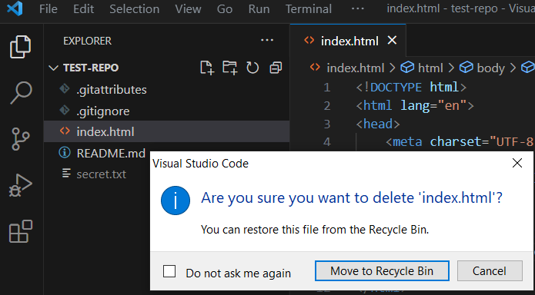

Delete index.html in VSC, changes seen in GitHub Desktop

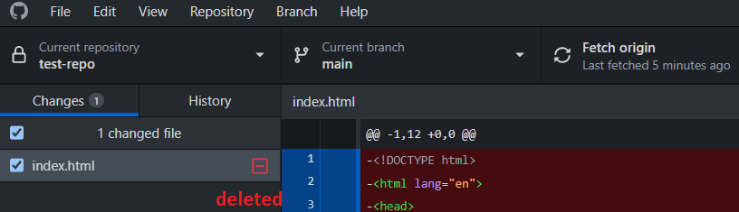

Commit to main on GitHub Desktop

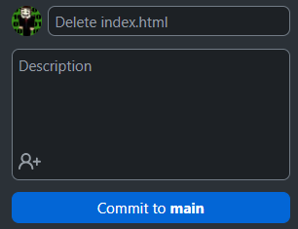

Click push origin on GitHub Desktop, Note: index.html on GitHub removed also

=== Retrieve older version of file from GitHub Desktop **(OH SHIT)** ===

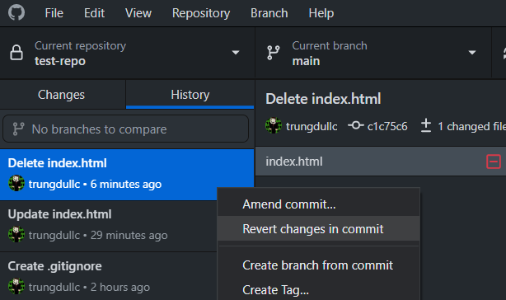

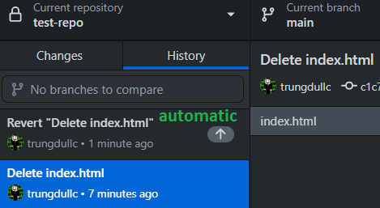

Click push origin on GitHub Desktop, Note: index.html on GitHub retrieved

=== Team Work, new features and bug branch on GitHub Desktop===

GitHub Desktop > Branch > New Branch : feature-1

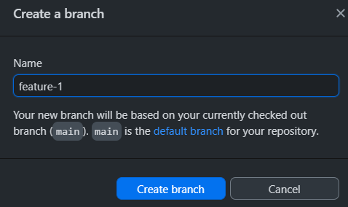

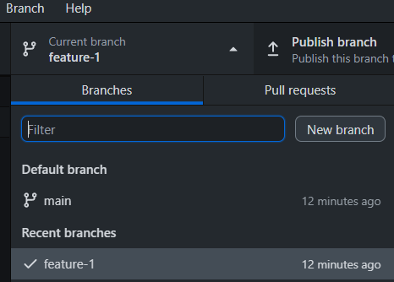

VSC create feature1.html, GitHub Desktop commit changes to feature-1

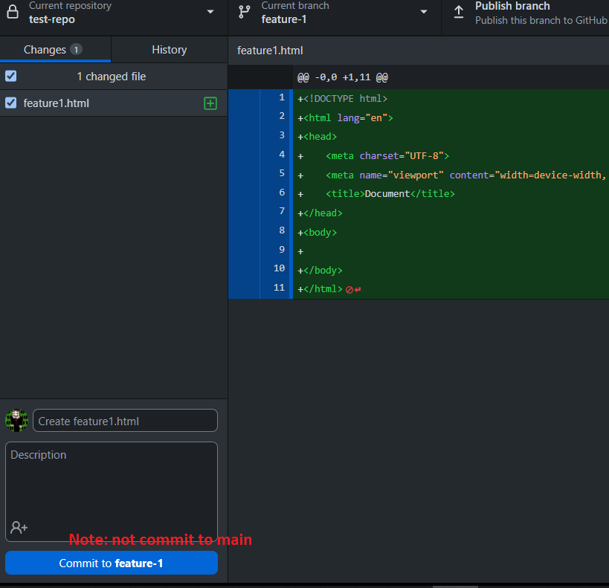

When fix and want to merge feature-1 to main (bad) **Note: pull request here team work !!!**

GitHub Desktop > Current branch: **main Note: Publish branch, then get on GitHub**

GitHub Desktop > Branch > Merge into current branch

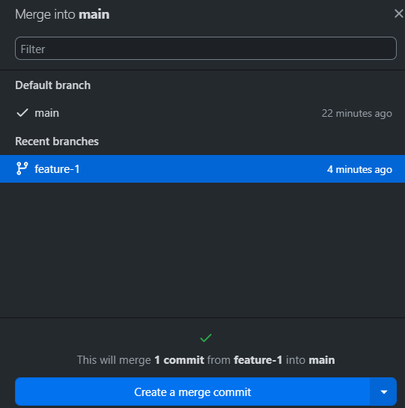

Click push origin on GitHub Desktop, Note: origin will now have feature1.html

**Note: GitHub Compare & pull request (work w/ team)**

